Week-1

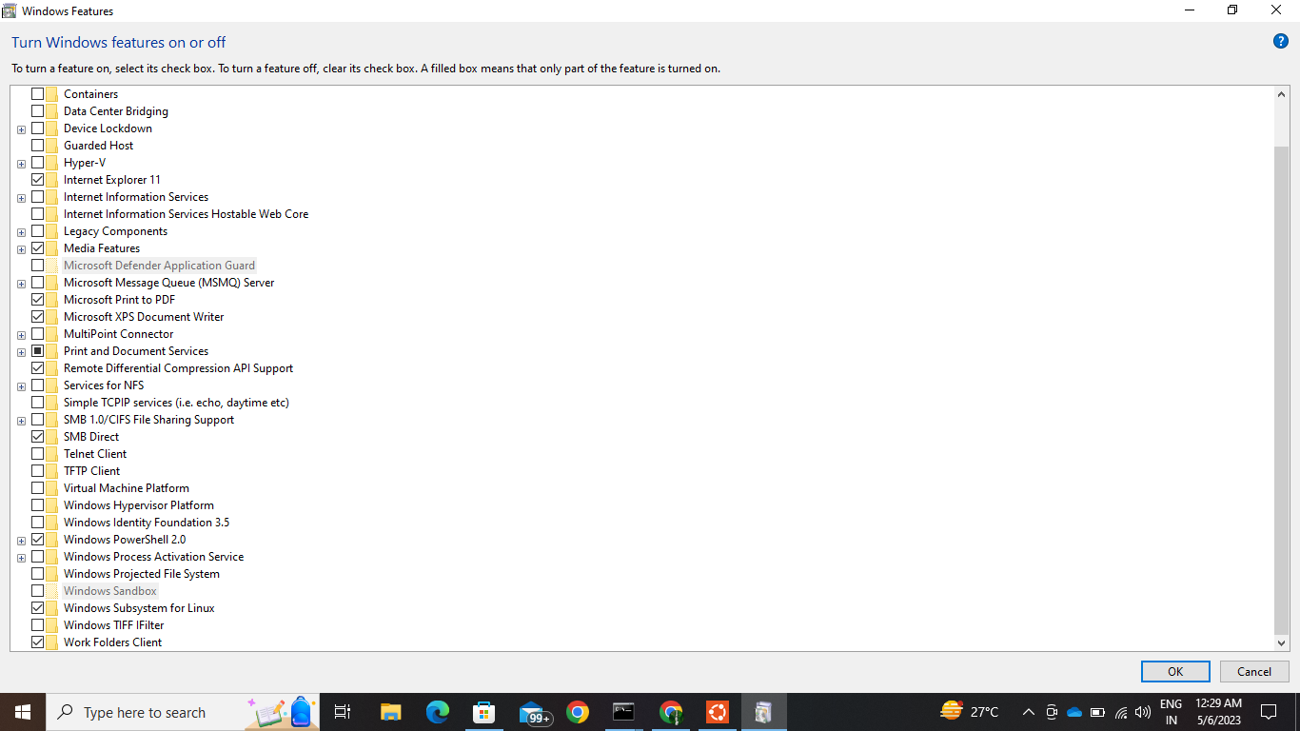

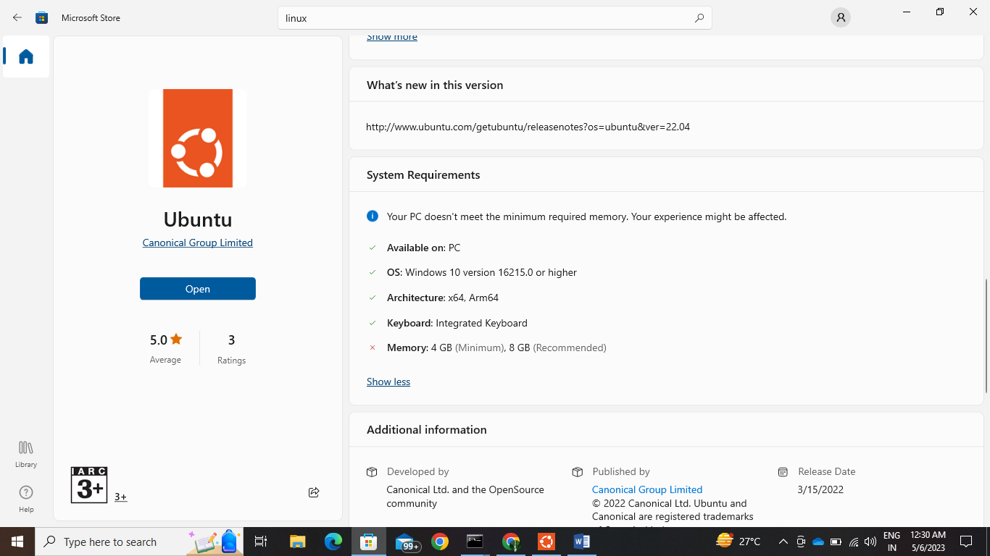

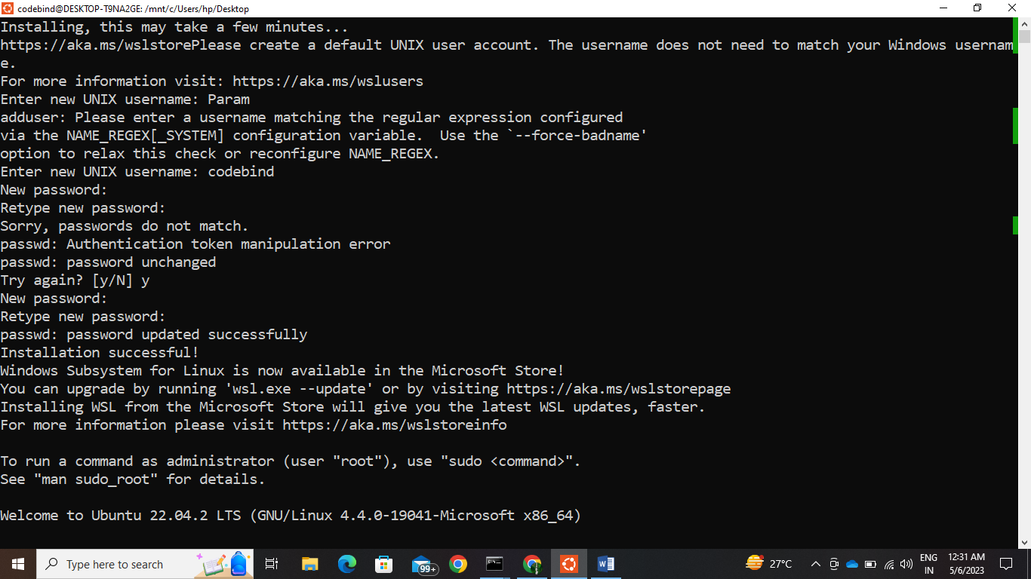

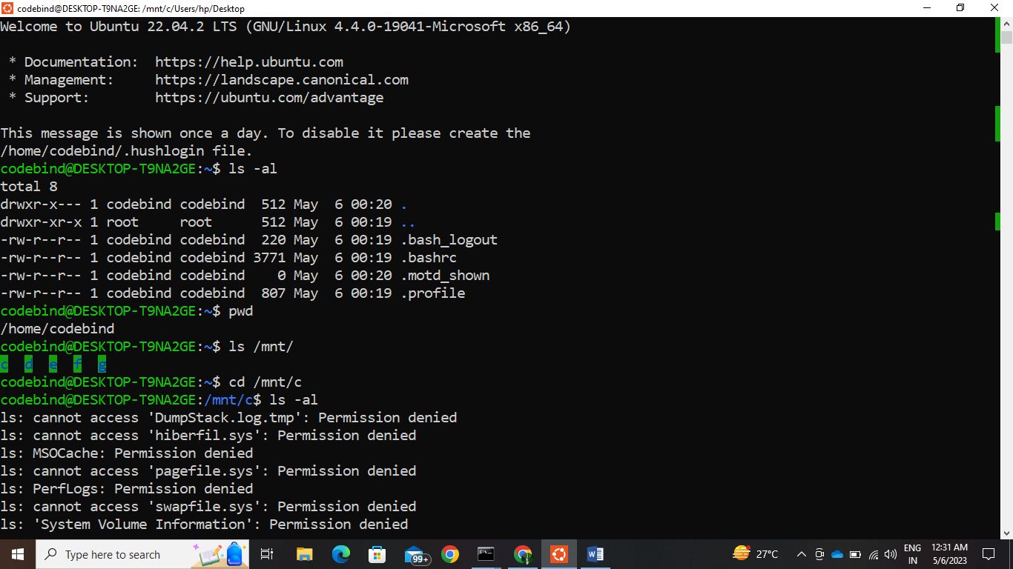

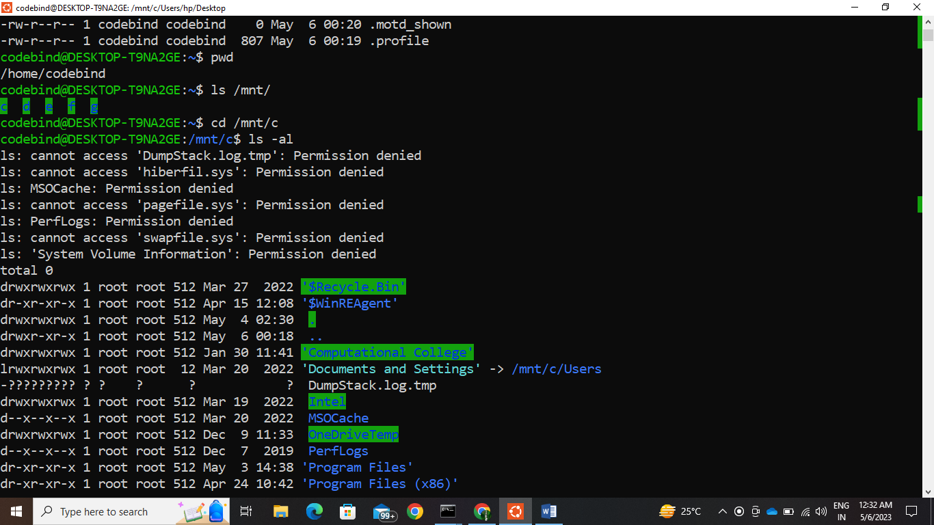

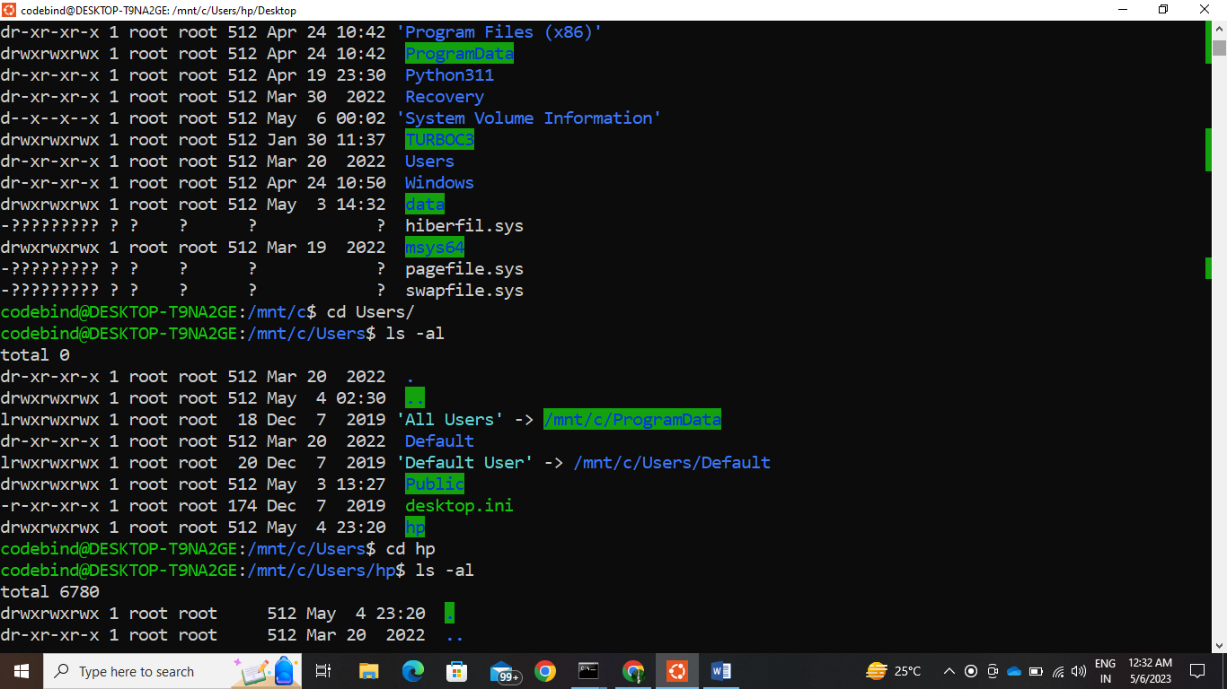

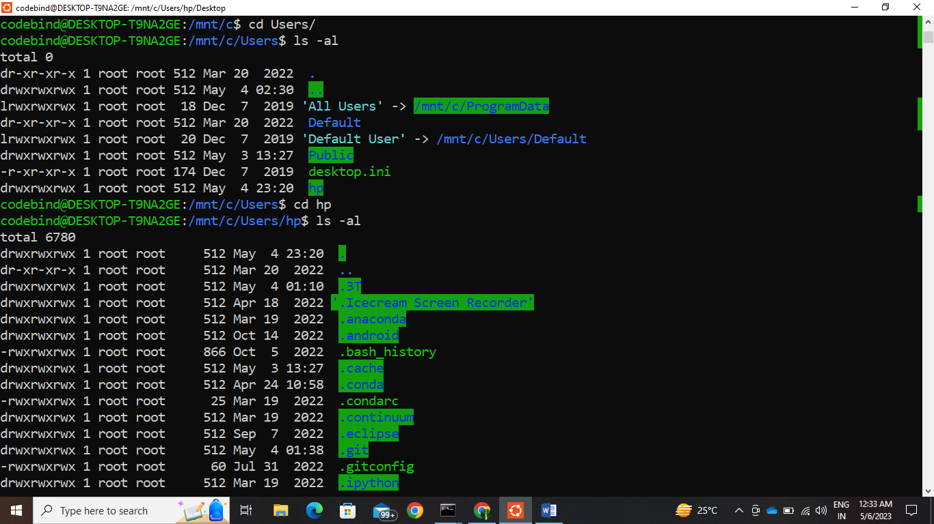

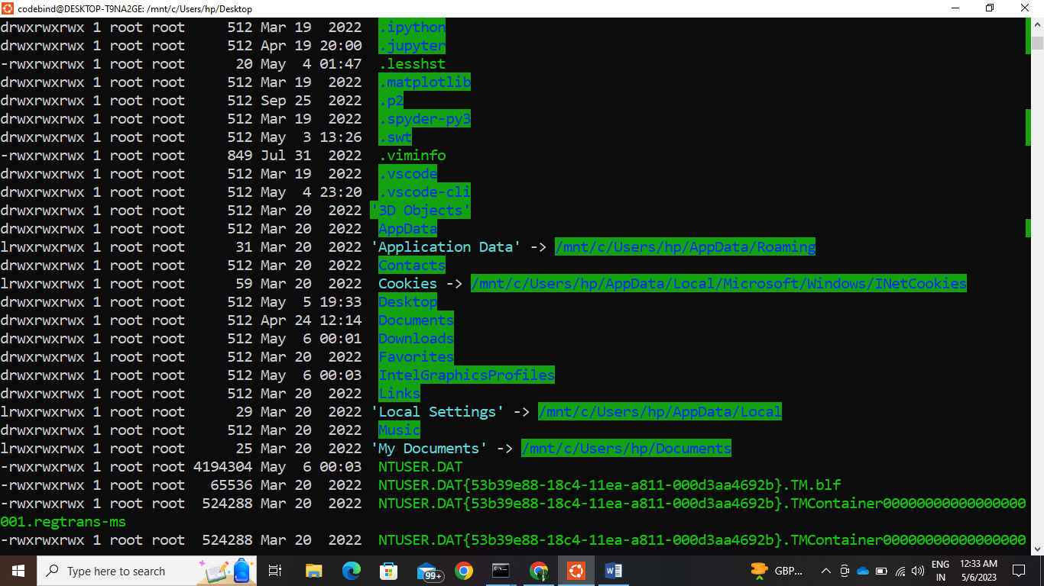

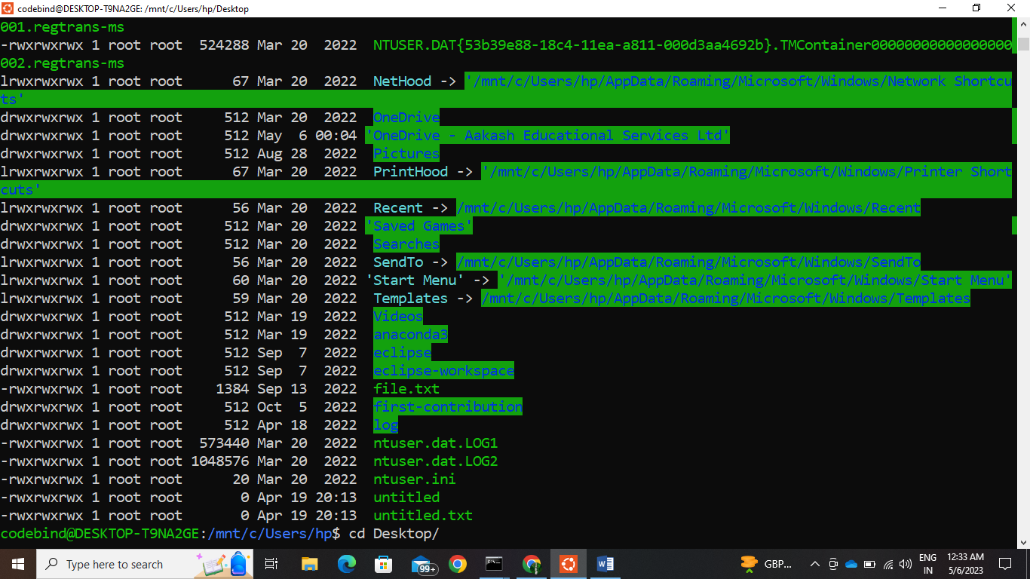

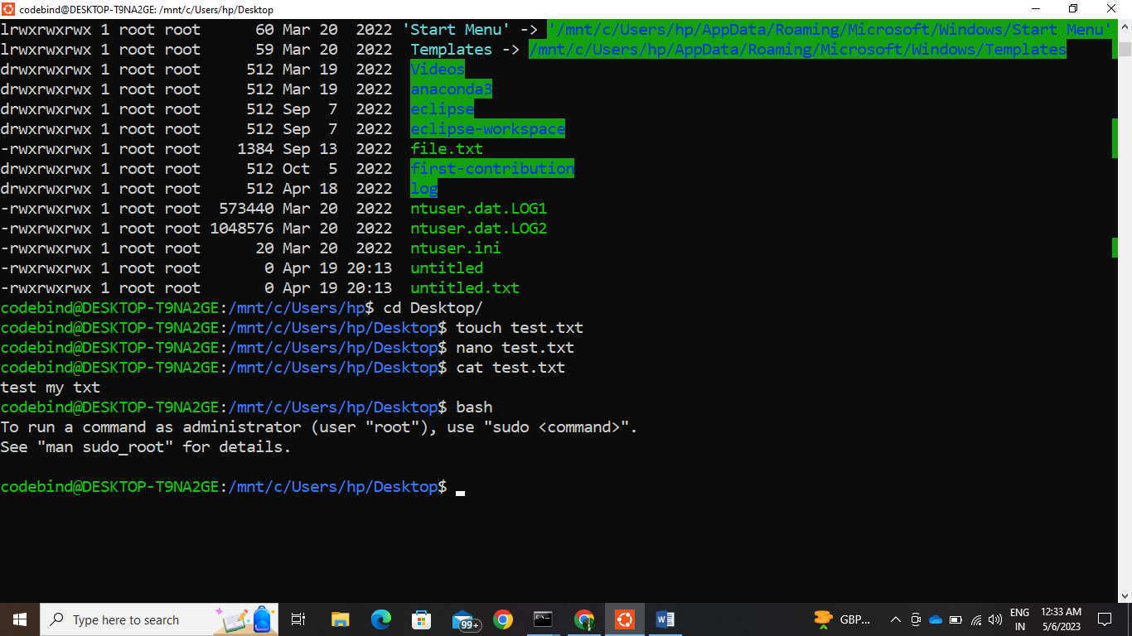

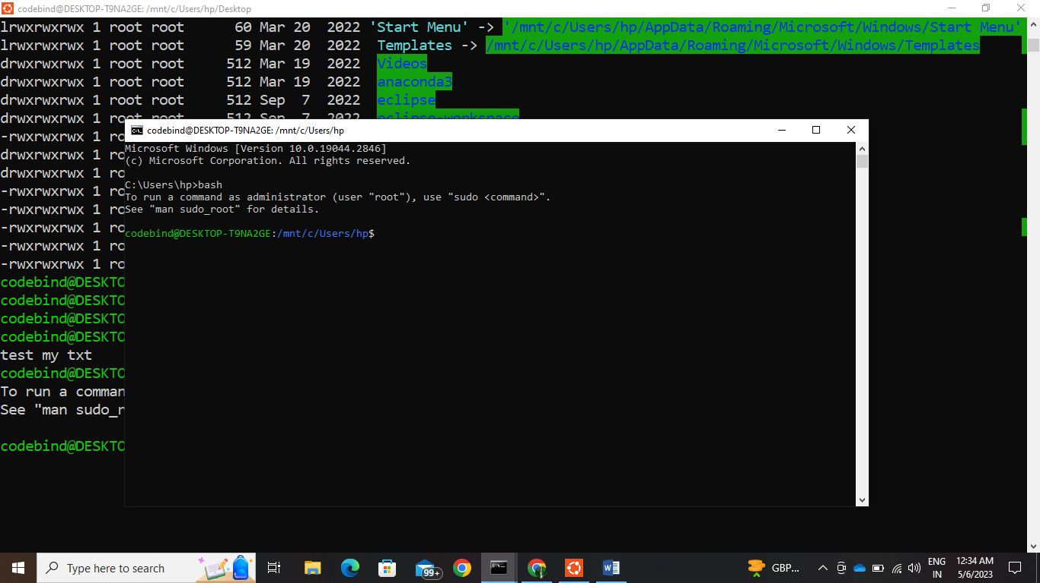

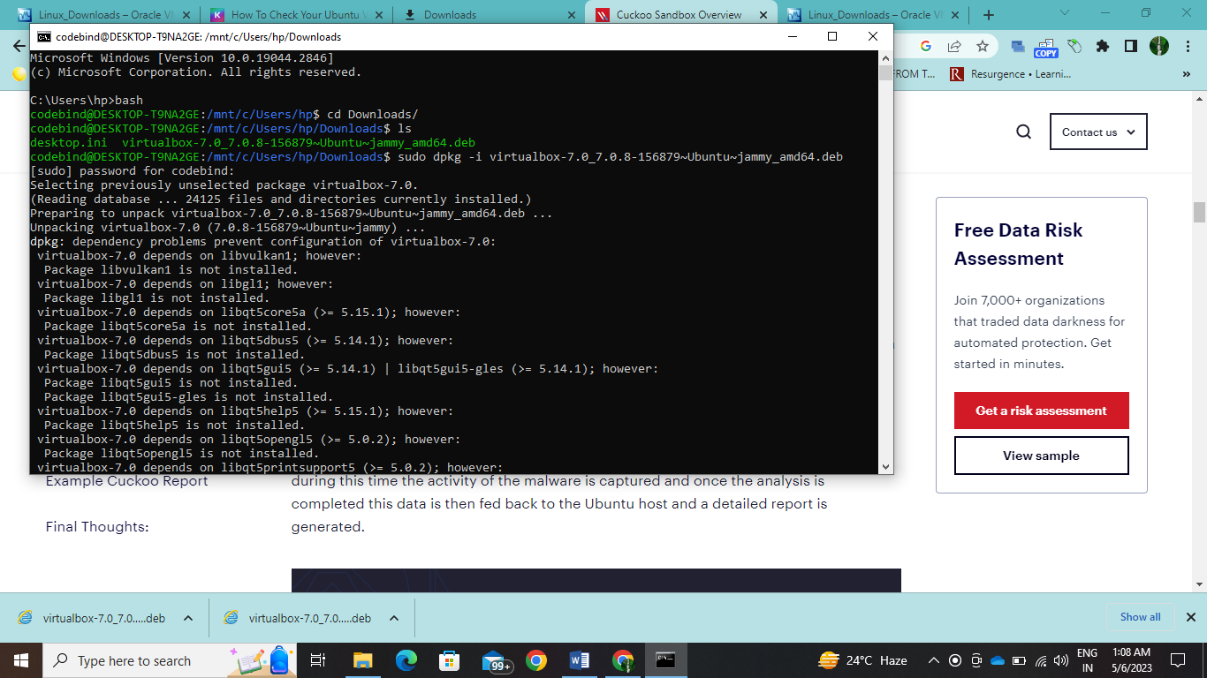

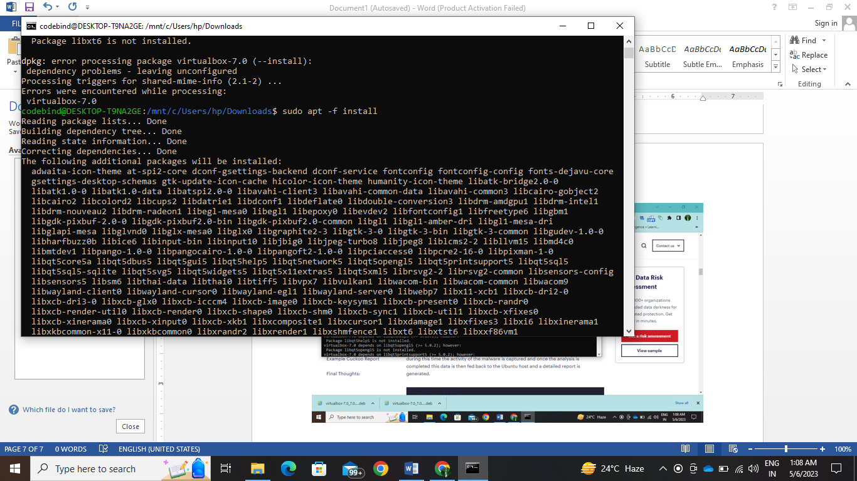

Linux

Week-2

In the context of web design and server hosting, GUARD primarily focuses on enhancing the security of web applications by implementing security controls, while M2Crypto provides the necessary cryptographic capabilities to secure data transmission, protect sensitive information, and establish secure connections between clients and servers.

In summary, Cuckoo Signatures are used by Cuckoo Sandbox to detect known malicious behavior, while the Cuckoo Analyzer is the component that performs the actual analysis of files, extracting relevant information and generating comprehensive reports. Together, they contribute to the automated detection and analysis of malware within the Cuckoo Sandbox framework.

While Python Pillow is focused on image processing and manipulation in Python, PE Studio is a specialized tool for analyzing Windows executable files, particularly PE files. These tools serve different purposes and are used in distinct domains.

In summary, network routing is the process of determining the path for data transmission, TCP dump is a tool for capturing and analyzing network traffic, TOR provides anonymous communication over the internet, and VPN creates secure and encrypted connections for private network access or data transmission.

Here are some key differences between the alternatives mentioned and Cuckoo Sandbox:

1. Joe Sandbox vs. Cuckoo Sandbox:
   * Joe Sandbox offers a more comprehensive feature set with advanced detection capabilities and behavior analysis.
   * It provides a user-friendly web interface for result analysis, making it accessible to a broader range of users.
   * Cuckoo Sandbox, on the other hand, is highly customizable and extensible, allowing for more flexibility in configuring analysis environments and integrating with other tools.
2. Hybrid Analysis vs. Cuckoo Sandbox:
   * Hybrid Analysis is an online service where users submit files and URLs for analysis, while Cuckoo Sandbox is typically set up and maintained locally.
   * Hybrid Analysis provides a centralized platform with a large community contributing to the analysis of samples, resulting in a broader knowledge base.
   * Cuckoo Sandbox offers more control and customization options, allowing for tailored analysis environments and workflow integration.
3. Any.Run vs. Cuckoo Sandbox:
   * Any.Run emphasizes real-time interaction with malware samples, allowing users to actively observe their behavior.
   * Any.Run offers a user-friendly web interface and encourages collaboration among users.
   * Cuckoo Sandbox provides more extensive customization options and is suitable for advanced users who require fine-grained control over analysis settings.
4. VMRay vs. Cuckoo Sandbox:
   * VMRay leverages virtual machine introspection (VMI) technology, offering advanced visibility into malware behavior at a low-level system perspective.
   * VMRay provides a comprehensive set of analysis techniques, including static, dynamic, and memory analysis.
   * Cuckoo Sandbox offers greater flexibility in terms of customization and integration but may require more expertise to set up and maintain.
5. Deep Instinct vs. Cuckoo Sandbox:
   * Deep Instinct focuses on endpoint protection and employs deep learning and artificial intelligence algorithms for malware detection and prevention.
   * Deep Instinct operates in real-time, providing immediate protection against known and unknown threats.
   * Cuckoo Sandbox is a more versatile and customizable solution for in-depth analysis, suitable for advanced users and researchers.

Overall, the differences lie in the specific features, analysis techniques, ease of use, customization options, and the target audience of each tool. It is important to evaluate these factors based on your specific requirements and objectives when choosing an alternative to Cuckoo Sandbox.

Cuckoo Sandbox utilizes various software components and tools to facilitate malware detection and analysis. Here are some of the key software components typically used by Cuckoo:

1. Virtualization Software: Cuckoo Sandbox relies on virtualization software to create isolated environments for executing malware samples. Commonly used virtualization platforms include VirtualBox, VMware, and QEMU. These platforms enable the execution of files within controlled and monitored virtual machines, preventing potential damage to the underlying host system.
2. Operating System: Cuckoo Sandbox supports multiple operating systems that can be used as the base for virtual machine instances. Commonly used operating systems include Windows, Linux, and macOS. The choice of the operating system depends on the type of malware being analyzed and the specific analysis requirements.
3. Cuckoo Agent: The Cuckoo Agent is a software component installed within the virtual machine instances. It collects runtime data, captures system events, and communicates with the Cuckoo Sandbox host. The agent helps in monitoring the behavior of the analyzed files, capturing relevant information, and transmitting it back to the analysis host for processing.
4. Analysis Components: Cuckoo Sandbox incorporates various analysis components to extract information and perform different types of analysis. These components include:
   * Memory Analysis Tools: Tools such as Volatility or Rekall are used to analyze the memory of the virtual machines, allowing for the detection of malicious processes, injected code, and other memory-based artifacts.
   * Network Analysis Tools: Wireshark or tcpdump are often utilized to capture and analyze network traffic generated by the analyzed files. This helps identify suspicious network connections, communication protocols, or malicious activities.
   * Behavior Analysis Tools: Cuckoo Sandbox uses a range of tools to monitor and analyze the behavior of the files. These may include API monitoring tools, system call monitors, registry monitoring tools, and file system monitoring tools. Examples include Sysmon, Regshot, and Procmon.
5. Reporting and Analysis Interfaces: Cuckoo Sandbox provides reporting and analysis interfaces to examine the results of the analysis. These interfaces may be web-based or command-line interfaces, offering detailed reports on the behavior, activities, and potential indicators of malware. These interfaces allow security analysts to interpret the results, investigate identified threats, and make informed decisions.

These software components, in conjunction with the customizable configurations and rules, enable Cuckoo Sandbox to detect and analyze malware effectively, providing valuable insights for cybersecurity professionals.

Cuckoo Sandbox is an open-source malware analysis framework designed for automated dynamic analysis of suspicious files and URLs. It allows security researchers and analysts to investigate potentially malicious samples in a controlled environment to understand their behavior and potential impact. Here are some key aspects of Cuckoo Sandbox:

Functionality:

1. Malware Analysis: Cuckoo Sandbox executes files within isolated virtual machine environments to observe their behavior, system interactions, and network activity.
2. Behavior Monitoring: Cuckoo Sandbox captures system events, network traffic, API calls, and other runtime activities to analyze the behavior of the analyzed files.
3. Reporting and Analysis: Cuckoo Sandbox generates comprehensive reports detailing the observed behavior, indicators of compromise (IOCs), network connections, and system modifications performed by the malware.
4. Extensibility: Cuckoo Sandbox is highly customizable and allows the integration of additional tools and plugins to enhance analysis capabilities or extend its functionality.
5. Community Support: Cuckoo Sandbox has an active and supportive community that contributes to its development, shares analysis techniques, and provides updates to improve its detection and analysis capabilities.

Components:

1. Host System: Cuckoo Sandbox runs on a host machine that manages the analysis process, orchestrates virtual machine instances, and collects analysis data.
2. Virtualization Software: Cuckoo Sandbox utilizes virtualization platforms such as VirtualBox, VMware, or QEMU to create isolated and controlled execution environments for malware analysis.
3. Analysis Components: Cuckoo Sandbox employs various tools and utilities, including memory analysis tools, network sniffers, and system monitoring tools, to collect and analyze data during the analysis process.
4. Cuckoo Agent: The Cuckoo Agent is installed within the virtual machine instances and facilitates communication with the analysis host, collecting runtime data, and transmitting it back for analysis.

Use Cases:

1. Malware Research: Cuckoo Sandbox is widely used by malware researchers to analyze and understand the behavior of new or unknown malware samples.
2. Incident Response: Cuckoo Sandbox assists incident response teams in investigating suspicious files or URLs, identifying malicious activities, and generating actionable intelligence for remediation.
3. Threat Intelligence: Cuckoo Sandbox aids in the generation of threat intelligence by analyzing and categorizing malware samples, identifying trends, and sharing information with the security community.

Cuckoo Sandbox is a powerful and flexible tool for automated malware analysis. Its capabilities, extensibility, and active community support make it a valuable asset in the fight against malware and cyber threats.

Installed Cuckoo

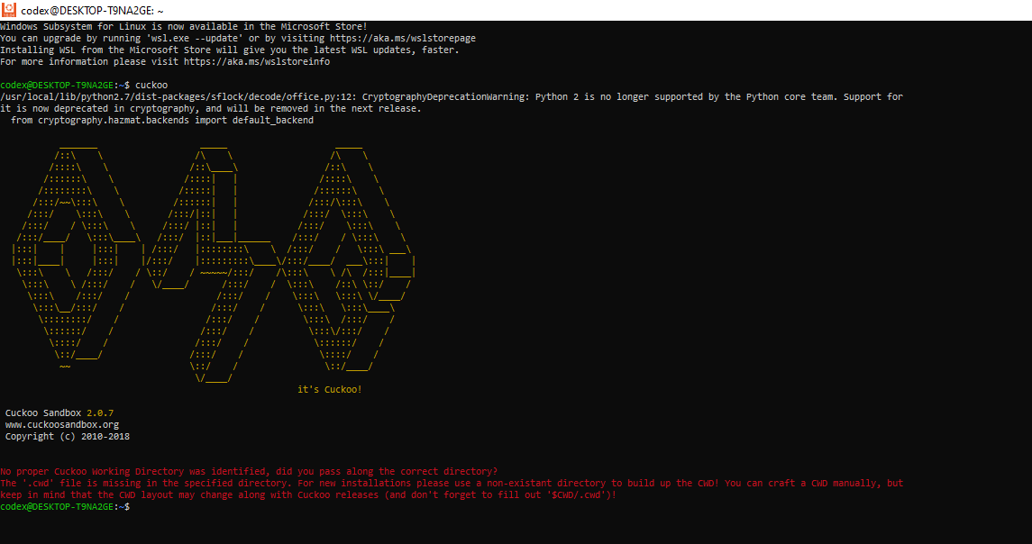Top of Form

Top of Form

Top of Form